Ansible Task-04

- Create ansible playbook to create ansible vault.
- Write a ansible playbook to install apache in linux and ubuntu machine by using when condition.
- Create ansible playbook using roles to configure LAMP stack
- Setup ansible AWX and explore the options.

Task 1: Create and use Ansible Vault

Objective
Ansible Vault encrypts sensitive information such as database passwords, application secrets, and credentials so they aren't stored as readable plain text.
Important: Vault encrypts files or variables. You do not need a special playbook just to create a vault; the ansible-vault command creates and manages encrypted files. A playbook can then consume those encrypted variables.

Step 1 — Verify Ansible
Run this on your Ubuntu control node:
ansible --version
Expected output will include something similar to:
ansible [core ...]
python version = ...
If Ansible is not installed, install it:
sudo apt update
sudo apt install ansible -y
Create a working directory:
mkdir -p ~/ansible-lab/vault
cd ~/ansible-lab/vault
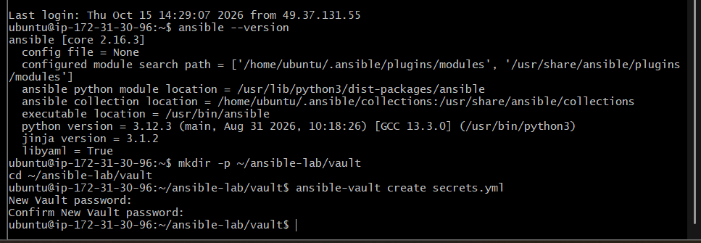

Step 2 — Create a Vault-encrypted variables file
Run:
ansible-vault create secrets.yml
It will ask you to enter and confirm a Vault password. Choose a password you can remember for this lab.
Your default text editor will open. Add the following YAML:
vault_username: admin
vault_password: LabDB@12345
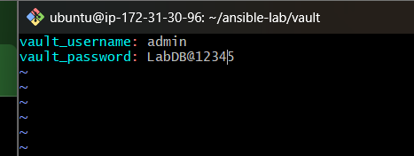
Save and close the editor.
The file secrets.yml is now encrypted. The example password is only for lab practice; don't use it for real systems.

Step 3 — Verify the encryption
head -n 2 secrets.yml
Expected output:
$ANSIBLE_VAULT;1.1;AES256
...
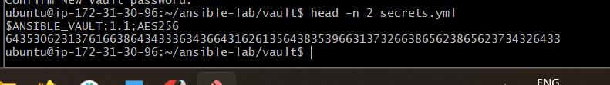
The remaining content should look like encrypted hexadecimal data, not your original username and password.

Step 4 — Create the playbook
Create the file:
nano vault-demo.yml
Paste the complete playbook:

---
- name: Demonstrate Ansible Vault
hosts: localhost
connection: local
gather_facts: false

vars_files:
- secrets.yml

tasks:
- name: Display the Vault username
ansible.builtin.debug:
msg: "Vault username is {{ vault_username }}"

- name: Confirm that the Vault password is loaded
ansible.builtin.debug:
msg: "Vault password loaded successfully"
Save and exit.
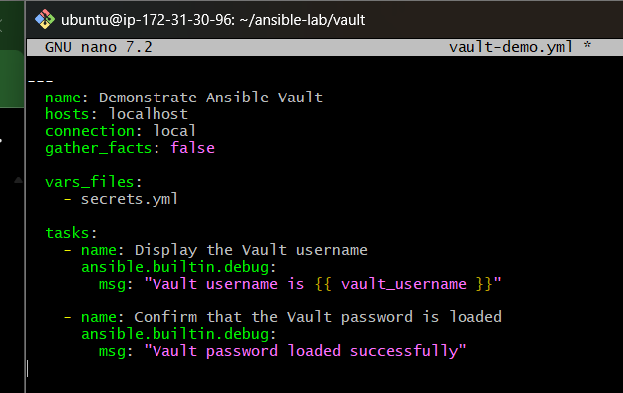
Notice that we deliberately do not print the password in the output.

Step 5 — Run the playbook
ansible-playbook vault-demo.yml --ask-vault-pass
Enter the Vault password when prompted.
Expected output:
TASK [Display the Vault username]
ok: [localhost] =>
msg: Vault username is admin

TASK [Confirm that the Vault password is loaded]
ok: [localhost] =>
msg: Vault password loaded successfully

PLAY RECAP
localhost : ok=2 changed=0 unreachable=0 failed=0

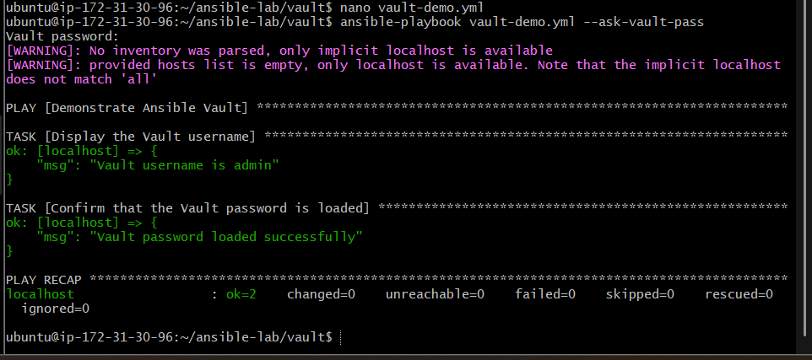

Step 6 — Explore Vault commands
Command | Purpose
ansible-vault view secrets.yml | View decrypted content without editing the file
ansible-vault edit secrets.yml | Edit encrypted content
ansible-vault rekey secrets.yml | Change the Vault password
ansible-vault encrypt vars.yml | Encrypt an existing plaintext file
ansible-vault decrypt secrets.yml | Decrypt a file back to plaintext

Task 2: Install Apache on Ubuntu and Linux using Ansible when conditions.

Objective
To create and execute an Ansible playbook that installs and starts the Apache web server on Ubuntu and Red Hat-based Linux machines using the when conditional statement.
The playbook uses Ansible facts to identify each target machine's operating system and execute the appropriate tasks:
- Ubuntu: Install the apache2 package and start the apache2 service.
- Amazon Linux / Red Hat: Install the httpd package and start the httpd service.
- Enable the Apache service to start automatically when the system boots.
- Verify that Apache is running and responding successfully on both worker nodes.

Step 1 — Check connectivity and operating systems
Run these commands from ~/ansible-lab:
ansible workers -i inventory.ini -m ping
Expected: both worker1 and worker2 return "ping": "pong".
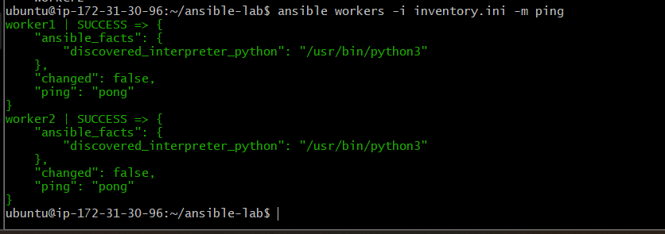
Now identify the operating systems:
ansible workers -i inventory.ini -m setup -a 'filter=ansible_distribution'
For example, you might see Ubuntu on one machine and Amazon Linux on another. We'll use the actual facts to select the correct installation task.

Step 2 — Create the complete playbook
Create a separate file so your existing playbooks remain unchanged:
cd ~/ansible-lab
nano install-apache-when.yml
Paste this complete playbook:

---
- name: Install Apache on Ubuntu and Red Hat-based Linux
hosts: workers
become: true
gather_facts: true

tasks:
- name: Install Apache on Ubuntu or Debian
ansible.builtin.apt:
name: apache2
state: present
update_cache: true
when: ansible_os_family == "Debian"

- name: Install Apache on Amazon Linux or Red Hat
ansible.builtin.dnf:
name: httpd
state: present
when: ansible_os_family == "RedHat"

- name: Start and enable Apache on Ubuntu
ansible.builtin.service:
name: apache2
state: started
enabled: true
when: ansible_os_family == "Debian"

- name: Start and enable Apache on Red Hat-based Linux
ansible.builtin.service:
name: httpd
state: started
enabled: true
when: ansible_os_family == "RedHat"

- name: Verify Apache is responding locally
ansible.builtin.uri:
url: http://127.0.0.1/
status_code: 200
return_content: false
register: apache_check
retries: 5
delay: 2
until: apache_check.status == 200
Save and exit.
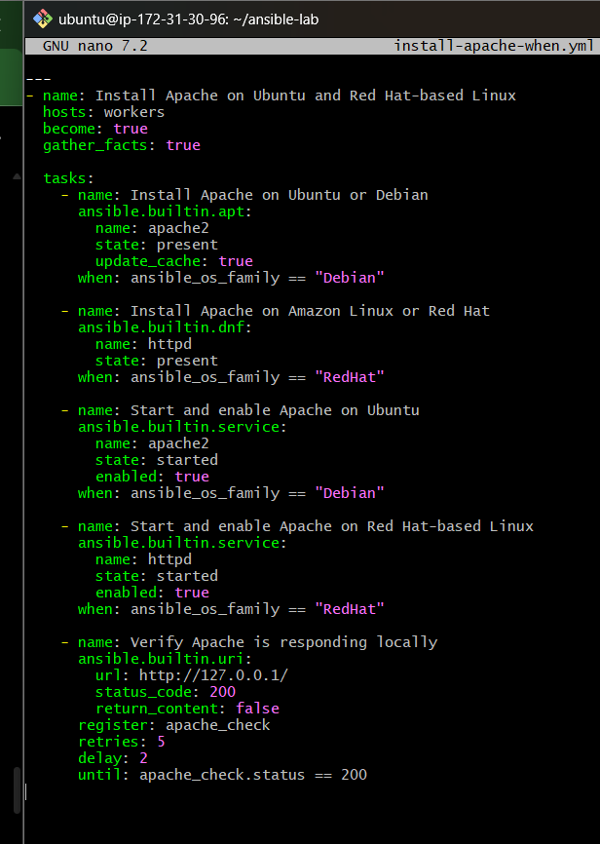

How the when condition works
Operating system family | Package installed | Service managed
Debian (Ubuntu) | apache2 | apache2
RedHat (Amazon Linux/RHEL) | httpd | httpd
Ansible gathers facts about each worker. The when condition evaluates those facts separately for each machine, so the correct tasks run on each host and the other OS-specific tasks are skipped.
become: true allows Ansible to use elevated privileges for installation and service management.

Step 3 — Validate the playbook
ansible-playbook -i inventory.ini install-apache-when.yml --syntax-check
Expected:
playbook: install-apache-when.yml

Step 4 — Execute the playbook
ansible-playbook -i inventory.ini install-apache-when.yml
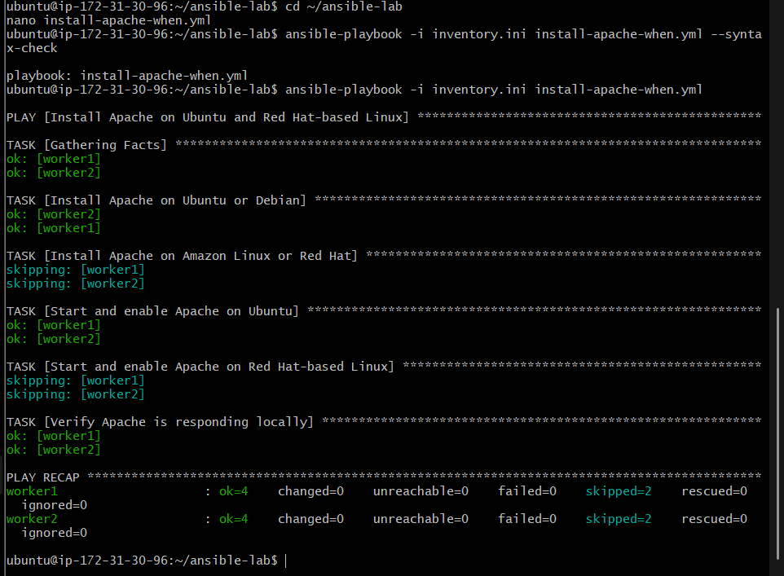
Look for output similar to:
TASK [Install Apache on Ubuntu or Debian]
skipping: [worker2]
changed: [worker1]

TASK [Start and enable Apache on Ubuntu]
ok: [worker1]

TASK [Verify Apache is responding locally]
ok: [worker1]
ok: [worker2]

PLAY RECAP
worker1 : ok=... changed=... unreachable=0 failed=0
worker2 : ok=... changed=... unreachable=0 failed=0
The exact hosts and task results depend on our workers' operating systems and whether Apache is already installed. If either machine uses an unsupported OS family, the playbook won't install Apache there; we'll adapt it based on our OS output.

Step 5 — Verify Apache on both workers
ansible workers -i inventory.ini -b -m shell -a \
'if command -v apache2 >/dev/null 2>&1; then systemctl is-active apache2; else systemctl is-active httpd; fi'
Expected output should contain active for each worker.
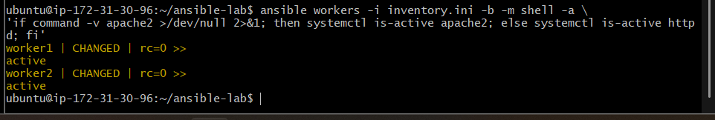

Outcome
- Successfully used Ansible when conditions to perform OS-specific tasks.
- Installed and started Apache on both worker nodes.
- Verified that both Apache services are active, with command return code 0.
- Learned how Ansible facts and conditional execution support automation across different Linux distributions.

Task 3: Configure a LAMP stack using Ansible roles

Objective
To automate the installation and configuration of a LAMP stack on Linux servers using reusable Ansible roles. The LAMP stack consists of Linux, Apache, MySQL/MariaDB, and PHP.
The playbook will use separate roles to install and configure each component, making the automation modular, reusable, and easier to maintain.

Architecture and workflow
Ansible Control Node
Ubuntu · lamp.yml
Role 1: Apache
Install and start the web server
Role 2: Database
Install and start MariaDB
Role 3: PHP
Install PHP and Apache integration
LAMP stack installed
Web server + database + PHP runtime
We'll use our existing Ansible control node and inventory.ini with worker1 and worker2. Before installation, we need to identify their Linux distributions so the roles use compatible package names.

Step 1 — Identify the operating systems
On your Ansible control node, run:
cd ~/ansible-lab

ansible workers -i inventory.ini -m setup \
-a 'filter=ansible_distribution'
Expected output will identify the distribution of each worker, for example:
worker1: Ubuntu
worker2: Amazon
The actual output may differ. This matters because Ubuntu uses packages such as apache2 and php, while Amazon Linux generally uses httpd and distribution-specific PHP packages.
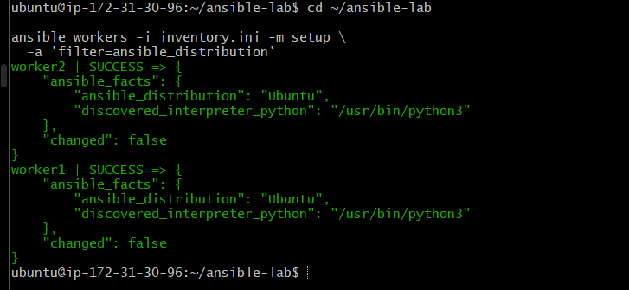

Step 2 — Create the role directory structure
After confirming the operating systems, create the following structure:
cd ~/ansible-lab

mkdir -p roles/apache/tasks
mkdir -p roles/database/tasks
mkdir -p roles/php/tasks
mkdir -p roles/php/templates

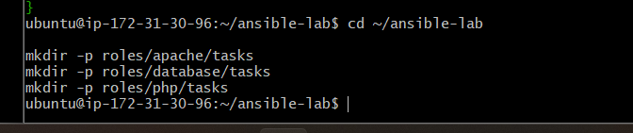
our project will look like this:
ansible-lab/
├── inventory.ini
├── lamp.yml
└── roles/
├── apache/
│ └── tasks/
│ └── main.yml
├── database/
│ └── tasks/
│ └── main.yml
└── php/
├── tasks/
│ └── main.yml
└── templates/
What are roles? Roles organize related Ansible tasks into reusable directories. The main playbook calls the roles in order, rather than containing every installation task itself.

Verify the directory structure
Run:
find roles -type d
You should see the apache, database, and php role directories and their task folders.

Step 3 — Configure the Apache role
Create the task file:
nano roles/apache/tasks/main.yml
Paste:

---
- name: Install Apache
ansible.builtin.apt:
name: apache2
state: present
update_cache: true

- name: Start and enable Apache
ansible.builtin.service:
name: apache2
state: started
enabled: true
Save and exit.
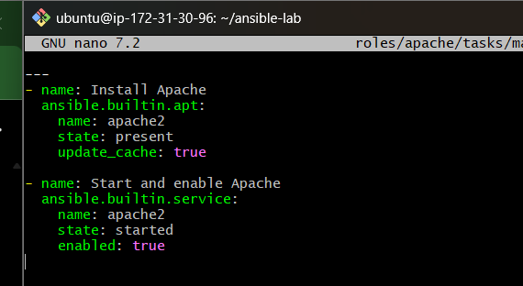

Step 4 — Configure the database role
We'll use MariaDB, a MySQL-compatible database server.
nano roles/database/tasks/main.yml
Paste:

---
- name: Install MariaDB server
ansible.builtin.apt:
name: mariadb-server
state: present
update_cache: true

- name: Start and enable MariaDB
ansible.builtin.service:
name: mariadb
state: started
enabled: true
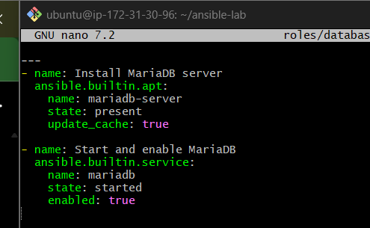

Save and exit.

Step 5 — Configure the PHP role
Create the PHP task file:
nano roles/php/tasks/main.yml
Paste:

---
- name: Install PHP and Apache integration
ansible.builtin.apt:
name:
- php
- libapache2-mod-php
- php-mysql
state: present
update_cache: true

- name: Ensure Apache is started
ansible.builtin.service:
name: apache2
state: started
enabled: true
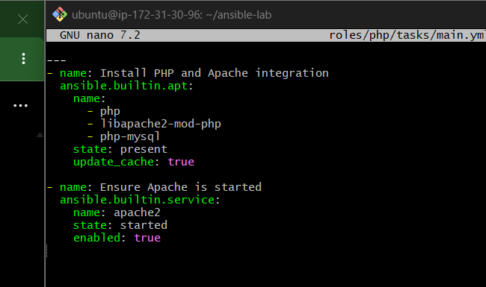
Save and exit.
These packages install PHP, connect PHP to Apache, and provide PHP's MySQL/MariaDB driver.

Step 6 — Create the main playbook
Create the file:
nano lamp.yml
Paste the complete playbook:

---
- name: Configure LAMP stack using Ansible roles
hosts: workers
become: true
gather_facts: true

roles:
- apache
- database
- php
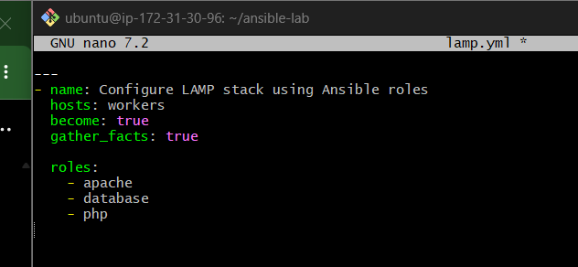
Save and exit.
Ansible will execute the roles in the order listed: Apache, database, and PHP.

Step 7 — Validate the project
Check the directory structure:
find roles -type f
Expected files:
roles/apache/tasks/main.yml
roles/database/tasks/main.yml
roles/php/tasks/main.yml
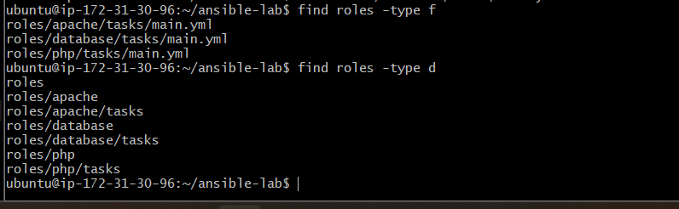
Check the playbook syntax:
ansible-playbook -i inventory.ini lamp.yml --syntax-check
Expected:
playbook: lamp.yml

Step 8 — Run the LAMP installation
Run:
ansible-playbook -i inventory.ini lamp.yml
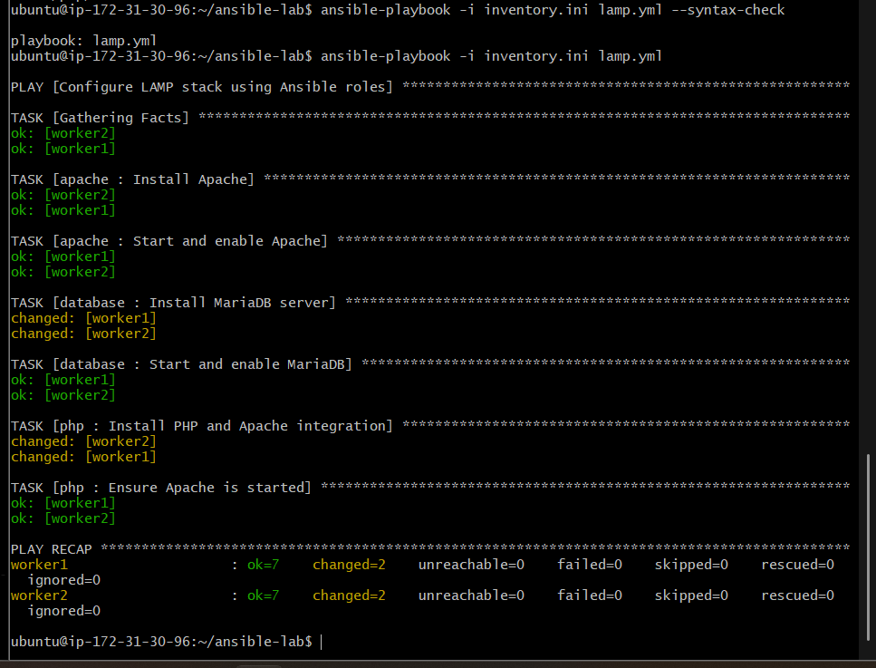
The first execution may take a few minutes because packages must be downloaded and installed on both EC2 workers.
Expected final recap: both workers should show unreachable=0 and failed=0.

Step 9 — Verify the LAMP stack
Run these checks separately.
1. Apache service
ansible workers -i inventory.ini -b -m command \
-a 'systemctl is-active apache2'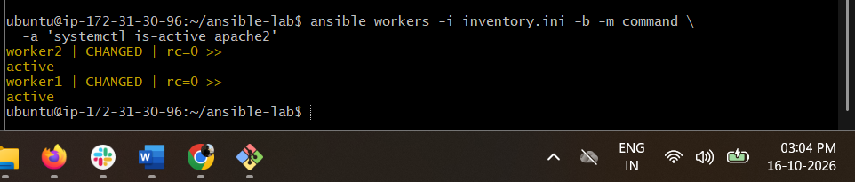
Expected: active on both workers.
2. MariaDB service
ansible workers -i inventory.ini -b -m command \
-a 'systemctl is-active mariadb'
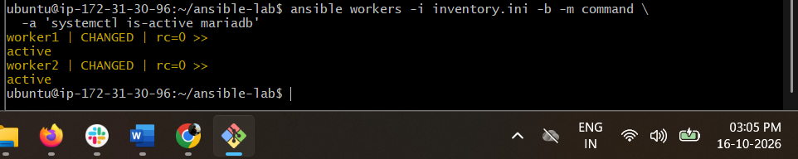
Expected: active on both workers.
3. PHP version
ansible workers -i inventory.ini -b -m command \
-a 'php --version'
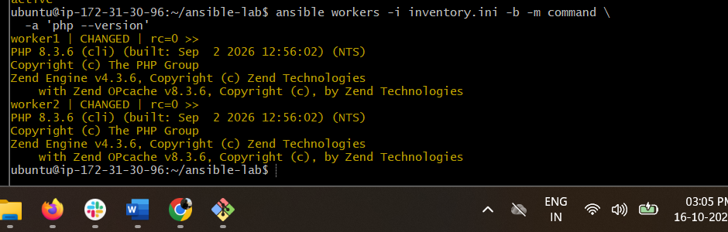
Expected: PHP version information on both workers.
4. Apache HTTP response
ansible workers -i inventory.ini -b -m uri \
-a 'url=http://127.0.0.1/ status_code=200'
Expected: HTTP status 200 from both workers.
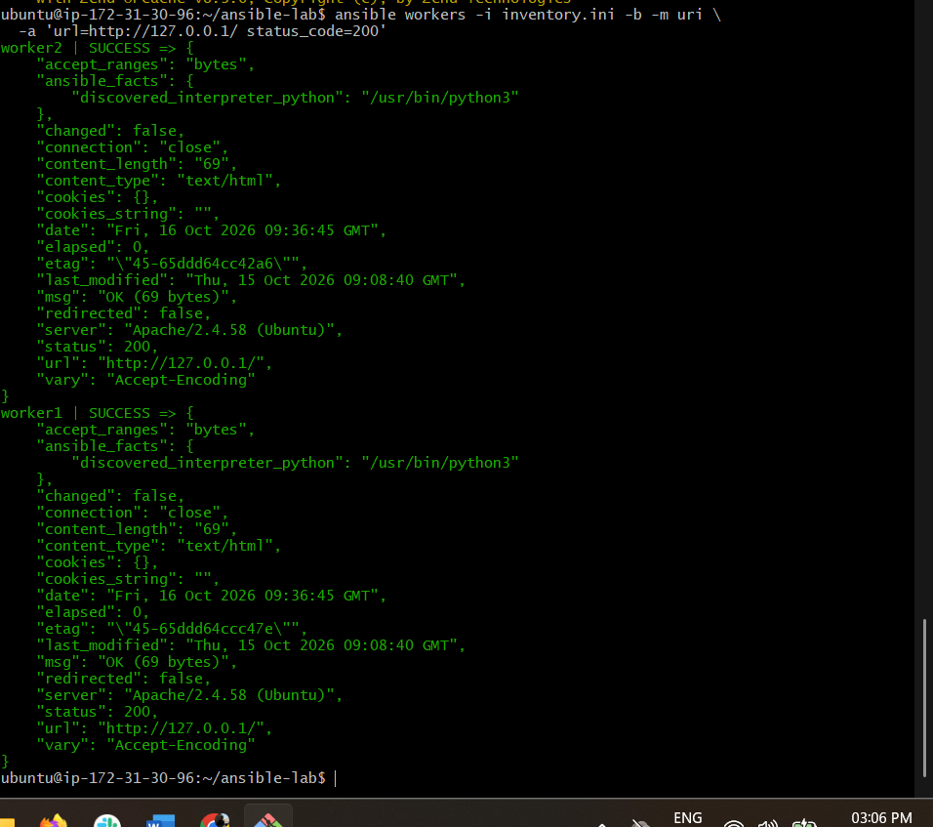

Outcome
- Created separate Ansible roles for Apache, MariaDB, and PHP.
- Used a main playbook, lamp.yml, to execute the roles in sequence.
- Successfully installed and started Apache and MariaDB on both worker nodes.
- Verified PHP installation on both workers.
- Confirmed Apache returns HTTP status 200 on both workers.
- Practiced reusable role-based automation, improving playbook organization and maintainability.
Result: The LAMP stack is installed and verified on both Ubuntu worker nodes.

Task 4 — Set up Ansible AWX and explore its options

1. Objective
Install AWX locally on an existing Minikube Kubernetes cluster using the official AWX Operator, access the AWX dashboard through port forwarding, and verify that all required components are running successfully.

2. What is AWX?
AWX is an open-source web-based interface for managing and executing Ansible automation.
It provides a centralized platform to:
- Manage inventories and hosts.
- Store credentials securely.
- Create and execute job templates.
- Manage Ansible projects and playbooks.
- Monitor automation jobs and their execution results.
The AWX Operator manages the deployment and lifecycle of AWX resources inside Kubernetes.

3. Architecture
Administrator
|
| Browser
v
http://localhost:8080
|
| kubectl port-forward
v
Minikube Cluster
Namespace: awx
|
+-----------+-----------+
| |
v v
AWX Web Pod AWX Task Pod
(Web Interface) (Automation)
| |
+-----------+-----------+
|
v
PostgreSQL Pod
(AWX Database)

AWX Operator
|
v
Manages AWX Resources

Component responsibilities
Component | Responsibility
AWX Operator | Manages AWX resources and deployments.
AWX Web | Provides the browser-based interface and API.
AWX Task | Executes and manages automation jobs.
PostgreSQL | Stores AWX application data.
Migration pod | Applies database schema migrations.
Minikube | Provides the local Kubernetes environment.
Port forwarding | Makes the AWX service accessible on the local computer.

4. Prerequisites
The following environment was used:
- Windows 11.
- Docker Desktop with the WSL2 backend.
- Minikube v1.39.0.
- Kubernetes v1.37.0.
- kubectl v1.36.1.
- Git for Windows.
- An existing, running Minikube cluster.
The existing Minikube cluster was preserved throughout this task.

5. Implementation

Step 1: Verify the existing Minikube cluster
Run the following in PowerShell:
minikube status
kubectl get nodes
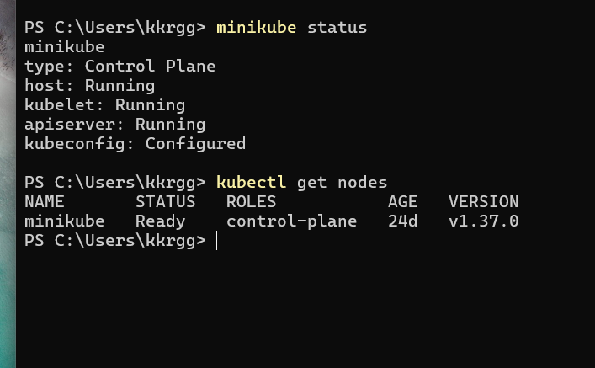
Confirm that Minikube is running and the Kubernetes node is Ready.

Step 2: Create a working directory

New-Item -ItemType Directory -Force -Path "$HOME\awx-lab"
Set-Location "$HOME\awx-lab"
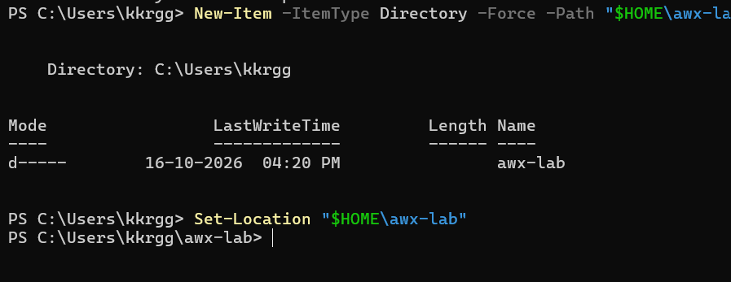
This directory stores the AWX Operator files and the AWX custom resource configuration.

Step 3: Download the official AWX Operator

git clone --branch 2.19.1 https://github.com/ansible/awx-operator.git
Move into the repository:
Set-Location "$HOME\awx-lab\awx-operator"
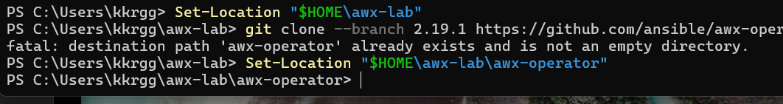
The repository contains the Kubernetes manifests, Custom Resource Definition (CRD), and configuration needed to deploy AWX.

Step 4: Install the AWX Operator
Apply the default operator configuration:
kubectl apply -k "$HOME\awx-lab\awx-operator\config\default"
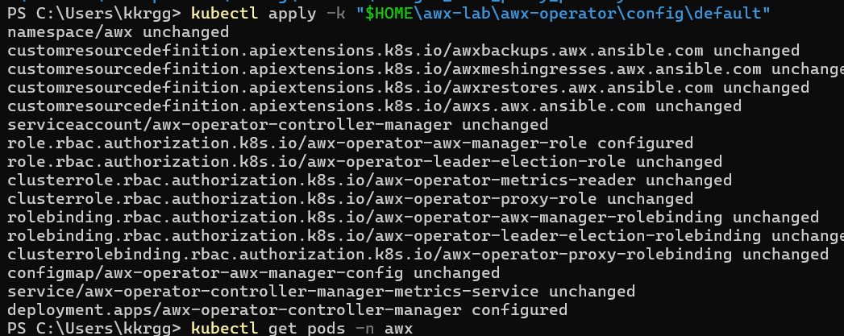
Verify that the namespace exists:
kubectl get namespaces
The installation creates the awx namespace and the required Kubernetes resources.

Step 5: Resolve the operator proxy image issue
The initial operator deployment encountered an image-pull problem with:
gcr.io/kubebuilder/kube-rbac-proxy:v0.15.0
The image reference was changed in the local operator configuration file:
config/default/manager_auth_proxy_patch.yaml
The replacement image reference was:
registry.k8s.io/kubebuilder/kube-rbac-proxy:v0.15.0
The updated configuration was reapplied:
kubectl apply -k "$HOME\awx-lab\awx-operator\config\default"
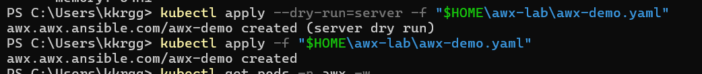
The operator deployment was subsequently verified as ready.

Step 6: Configure the AWX custom resource
Create the configuration file:
notepad "$HOME\awx-lab\awx-demo.yaml"
Add the following configuration:
---
apiVersion: awx.ansible.com/v1beta1
kind: AWX
metadata:
name: awx-demo
namespace: awx
spec:
web_resource_requirements:
requests:
cpu: 50m
memory: 128M

task_resource_requirements:
requests:
cpu: 50m
memory: 128M

ee_resource_requirements:
requests:
cpu: 50m
memory: 64M

postgres_storage_class: standard

postgres_storage_requirements:
requests:
storage: 8Gi

postgres_resource_requirements:
requests:
cpu: 10m
memory: 64Mi
Configuration explanation:
- apiVersion: Identifies the AWX custom resource API.
- kind: AWX: Requests an AWX installation.
- metadata.name: Names the installation awx-demo.
- metadata.namespace: Places it in the namespace watched by the operator.
- web_resource_requirements: Sets CPU and memory requests for the web component.
- task_resource_requirements: Sets requests for the task component.
- ee_resource_requirements: Sets requests for the execution environment component.
- postgres_storage_class: Uses Minikube's standard storage class.
- postgres_storage_requirements: Requests an 8 GiB persistent volume for PostgreSQL.
- postgres_resource_requirements: Sets PostgreSQL CPU and memory requests.
These are resource requests, not hard memory limits.

Step 7: Validate and create the AWX resource
First, validate the configuration against the Kubernetes API:
kubectl apply --dry-run=server -f "$HOME\awx-lab\awx-demo.yaml"
Then create the resource:
kubectl apply -f "$HOME\awx-lab\awx-demo.yaml"
The AWX Operator detects the custom resource and creates the supporting resources, including PostgreSQL, the web component, the task component, and the migration pod.
Important: The namespace must be awx. Creating the custom resource in the default namespace would place it outside the operator's configured watch namespace.

Step 8: Monitor the AWX deployment
Check the pods:
kubectl get pods -n awx
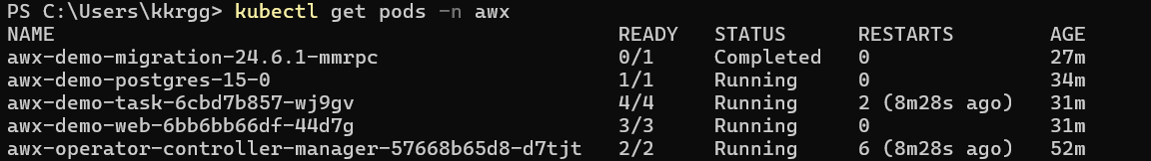
Initially, the task pod remained in Init:0/2 while waiting for database migrations.
Inspect the task pod logs:
kubectl logs <task-pod-name> -n awx -c init-database --tail=40
The logs showed:
[wait-for-migrations] Waiting for database migrations...
Inspect the migration pod logs:
kubectl logs <migration-pod-name> -n awx --tail=60
The migration logs showed database migrations being applied successfully. After migration completion, the task pod started.

Step 9: Verify the services
List services in the AWX namespace:
kubectl get svc -n awx
The AWX web service was:
awx-demo-service
It was a ClusterIP service listening on port 80.
A ClusterIP service is accessible inside the Kubernetes cluster by default, so port forwarding was used for local browser access.

Step 10: Expose the AWX web interface locally
Run this command in PowerShell:
kubectl port-forward -n awx svc/awx-demo-service 8080:80
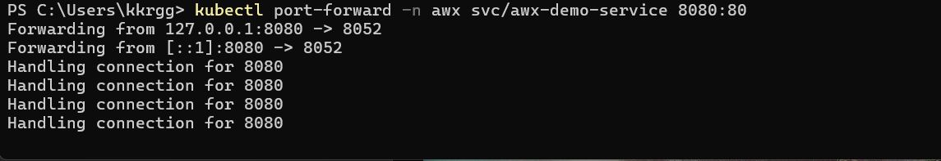
The verified output was:
Forwarding from 127.0.0.1:8080 -> 8052
Forwarding from [::1]:8080 -> 8052
Keep this terminal open while accessing AWX.
Open the following URL in a browser:
http://localhost:8080
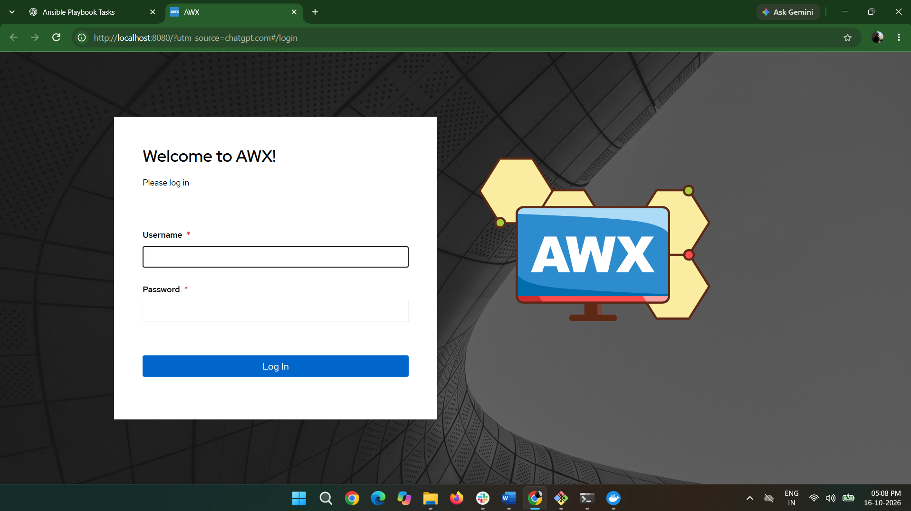
The AWX login page appeared successfully.

Step 11: Retrieve the administrator password
The administrator password was retrieved from the Kubernetes Secret:
kubectl get secret awx-demo-admin-password -n awx -o jsonpath="{.data.password}" | ForEach-Object { [System.Text.Encoding]::UTF8.GetString([System.Convert]::FromBase64String($_)) }
The login username was:
admin
The password was entered in the AWX login page. The dashboard appeared successfully.
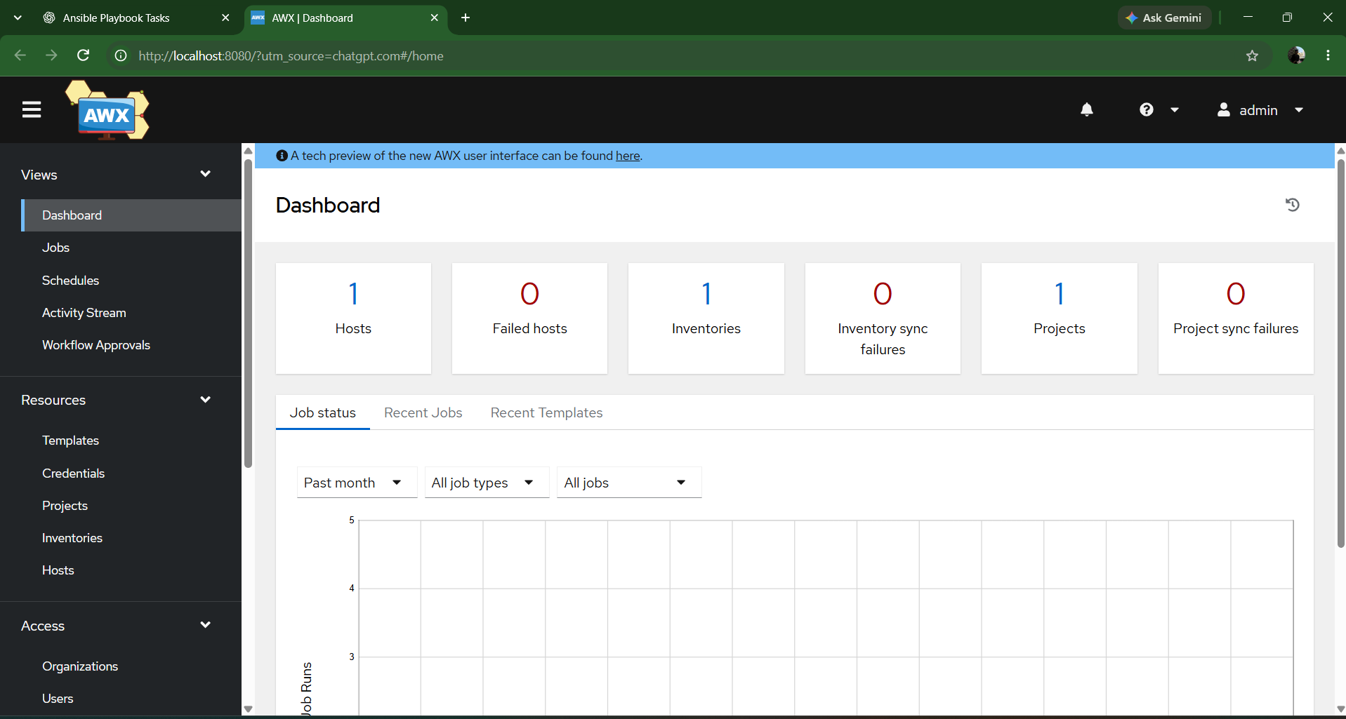

6. Final Verification
The final pod status was:
Pod | Expected/final status
awx-demo-postgres-15-0 | 1/1 Running
awx-demo-web-6bb6bb66df-44d7g | 3/3 Running
awx-demo-task-6cbd7b857-wj9gv | 4/4 Running
AWX migration pod | Completed
AWX Operator pod | 2/2 Running
The AWX service was accessible through http://localhost:8080, and the administrator successfully logged in and reached the dashboard.
The operator had restarted several times during installation. Although it was running at final verification, its restart count should be monitored if problems recur.

7. Troubleshooting Notes

Issue 1: Proxy image pull failure
Cause: The original gcr.io image reference could not be pulled.
Resolution: Updated the proxy image reference to registry.k8s.io/kubebuilder/kube-rbac-proxy:v0.15.0 and reapplied the operator configuration.

Issue 2: AWX task pod stuck in initialization
Cause: The task init container was waiting for database migrations to finish.
Resolution: Inspected the task init-container logs and migration logs. The migration process completed, after which the task pod became ready.

Issue 3: AWX service not directly accessible from the browser
Cause: The AWX service was a ClusterIP, which is internal to the cluster by default.
Resolution: Used kubectl port-forward to map local port 8080 to the service's port 80.

Issue 4: Port-forward connection stops
Cause: The PowerShell process running kubectl port-forward was closed or interrupted.
Resolution: Restart the port-forward command in PowerShell. The Minikube cluster does not need to be recreated.

8. Outcome
Task 4 completed successfully.
AWX was deployed on the existing Minikube Kubernetes cluster using AWX Operator version 2.19.1. The database migrations completed, the PostgreSQL, web, and task components reached their running states, and the AWX dashboard was accessed successfully through local port forwarding.
The lab demonstrates Kubernetes custom resources, operators, pod initialization, persistent storage, service exposure, Secrets, and troubleshooting application startup dependencies.

